Vocabulary Instructional Routine Resource Chart
Unit 6, Week 4 African-American Inventors Vocabulary: allowed, powerful, invented, instrument, products, design
Tier 2 Words – Pinellas Co. Vocabulary Project (Isabelle Beck’s Work): devise, ingenious, investigate, superior
Vocabulary Words | devise * | ingenious * | invented | investigate * | powerful | superior *
Macmillan Glossary Definition | To think out; invent; plan | Cleverly inventive or resourceful | Made or thought of something for the first time | To examine, study or inquire | Mighty, very strong | Higher or greater
Additional Student Friendly Definitions | Dream up | Brilliant, clever | Created, thought up | Check into thoroughly | Having great power or force | Better, excellent
Examples | When you devise something, you think up an idea and figure out how it will work.  The students will devise a way to raise money for the class trip. | If someone is ingenious they are clever and full of imagination.  The magician was ingenious when he made the rabbit disappear. | If a person invented something, he or she made a new thing that did not exist before.  Thomas Edison invented the light bulb. | When you investigate something, you check into it and study it closely.  The police will investigate the cause of the accident. | If something is powerful, it is very strong.  A powerful wind knocked over some trees. | When something is superior it is very good or higher in quality than other things like it.  The Rays baseball team has superior pitching.  The cars of today are superior to those that were first invented.
Ask  (Student Interaction) | Tell your partner a plan you would devise to set up a story for Writers’ Workshop. | Tell your partner about an ingenious idea that you have thought of before. | Tell your partner what your life would be like had the light bulb not been invented. | Tell your partner something that you would like to investigate in science. | Tell your partner an antonym for powerful. | Tell your partner how you might become a superior reader.
Synonyms/Antonyms | Synonyms: brainstorm, construct, concoct, craft, create  Antonyms: borrow | Synonyms: crafty, creative, skillful, imaginative, innovative, resourceful  Antonyms: awkward, inept, incompetent | Synonyms: design, devise, formulate, dream up, envision, contrive  Antonyms: steal | Synonyms: delve, probe, pry, question, scrutinize, research  Antonyms: ignore | Synonym: forceful, strong, able  Antonyms: weak, incapable, ineffective | Synonyms: admirable, deluxe, distinguished, preferable, remarkable  Antonyms: bad, below, inferior, lower
Created by Karin Lewis, Bauder Elem

Vocabulary Words | devise | ingenious | invented | investigate | powerful | superior
Making Choices | If I say something that describes devise point to your brain and say devise. If I don’t, don’t say anything.  -a school play  -a science project  -an inventor’s invention | If I say something that describes ingenious make really big eyes while fanning your eyes with your hands and say ingenious. If I don’t, don’t say anything.  -Walt Disney  -the computer  -electric cars  -inventors with good ideas | If I say something that describes invented put your fingers together as if making something and say invented. If I don’t, don’t say anything.  -making a paper airplane just like your dad used to make  -writing a new song  -making up a new move your skateboard  -lying to your teacher | If I say something that describes investigate make a singular binocular over your eye and say investigate, If I don’t, don’t say anything.  -looking closely at an ant crawling on a leaf  -ignoring a strange person walking down the street  -a policeman answering a call about a burglary  -looking away when you see something new | If I say something that describes powerful make a muscle and say powerful.  -a tornado  -a feeling that you can do anything  -a kitten  -the president  -a piece of paper | If I say something that describes superior make a crown over your head and say superior. If I don’t, don’t say anything.  -an old car  -a brand new car with lots of power  -a computer from 1999  -a computer from 2010  -the best quarterback in college football
Questions, Reasons and Examples | Would you rather devise a new sandwich for the cafeteria OR a new playground for your school? Explain your idea. | Which is a more ingenious invention the rollercoaster or the slide? Why? | What is something you would have invented if you were one of the first settlers to arrive in America? Why? | If you kept noticing things missing from your desk would it be important to investigate the matter or leave it alone? Why? | Which kind of storm do you think is more powerful a tornado or a hurricane? Why? | Which is more superior in taste CapriSun or Gatorade? Why?
Relating Words | Would it be possible or impossible to devise a plan to save the planet (earth)? Why or why not? | If you came up with an ingenious idea for a new amusement park would you have a great or little imagination? | Would you be ingenious or incapable if you devised a plan that allowed people to live in space? Why? | Would it be easier to investigate a place that is familiar or unfamiliar to you? Why? | Which would be more powerful a house that was assembled with sticks or a house that was assembled with bricks? Why? | Would a car that is very powerful be more or less superior than a car that could only go 20 mph? Why?

Created by Karin Lewis, Bauder Elem

allowed Unit 6.4
When something is allowed, it means that it is permitted to happen. Unit 6.4

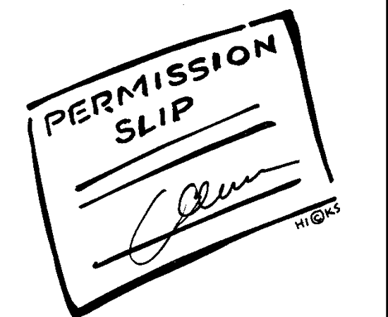
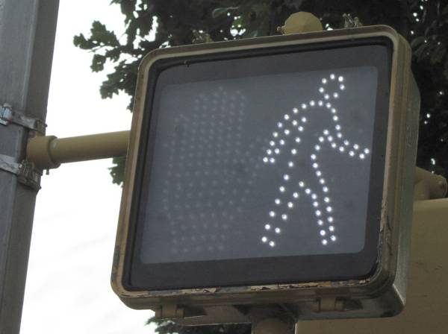

Unit 6.4
Synonyms: permit, grant, consent to, let, authorized

Antonyms: deny, forbid, prohibit Unit 6.4

powerful Unit 6.4
To be powerful means to have
great power and importance. Unit 6.4

  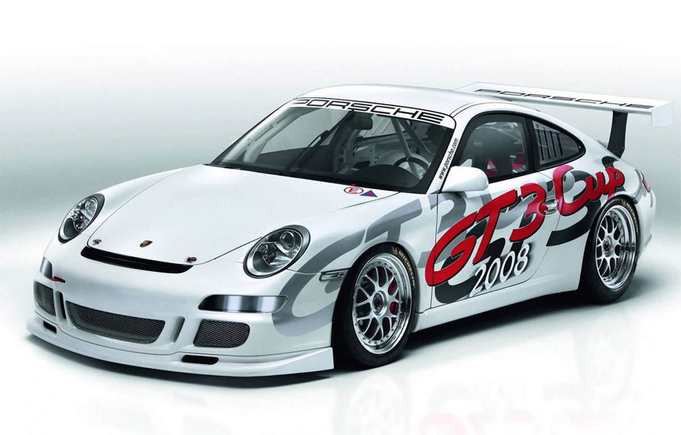 Unit 6.4
Synonyms: mighty, superhuman, invincible, forceful, dominant, commanding

Antonyms: weak, incompetent Unit 6.4

invented Unit 6.4
Something that is invented is
made or thought of for the first time. Unit 6.4

  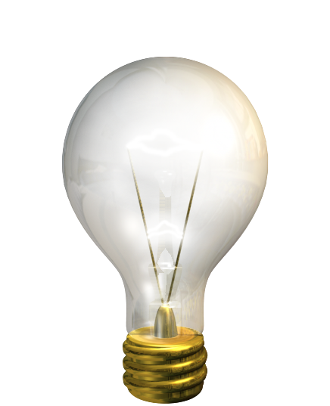 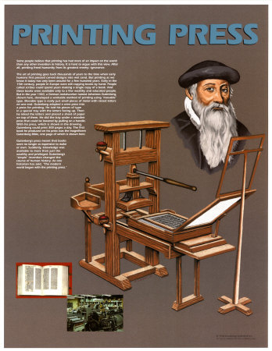 Unit 6.4
Synonyms: devised, designed, created

Antonyms: copy, duplicate Unit 6.4

instrument Unit 6.4
A tool that helps a person do
something is an instrument. Unit 6.4

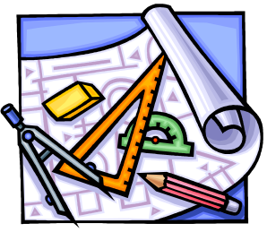  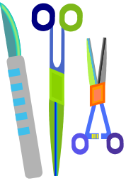 Unit 6.4
Synonyms: tool, apparatus, device, equipment

Antonyms: Unit 6.4

products Unit 6.4
Things that are made or
created are products. Unit 6.4

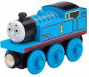   Unit 6.4
Synonyms: goods, stock, merchandise

Antonyms: Unit 6.4

design Unit 6.4
A plan for how something should
be made is a design. Unit 6.4

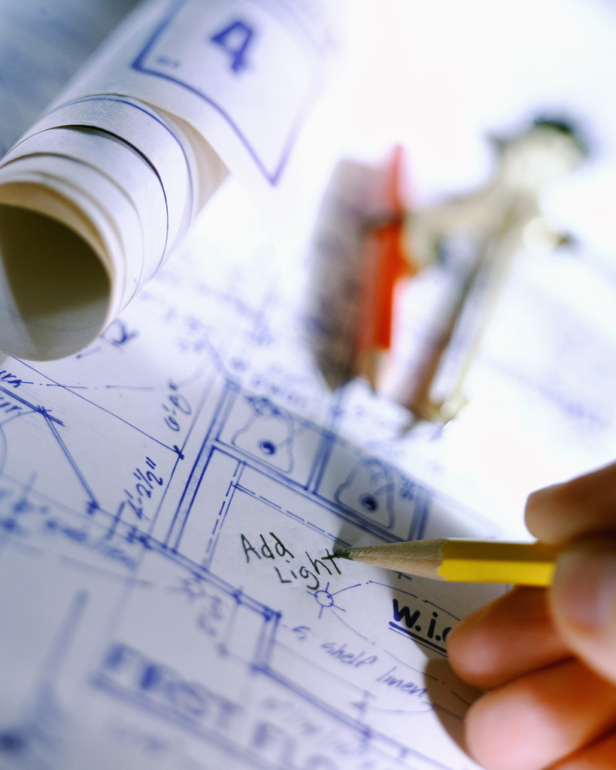 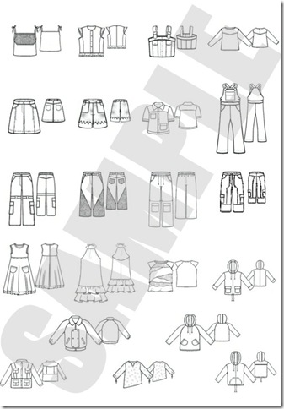 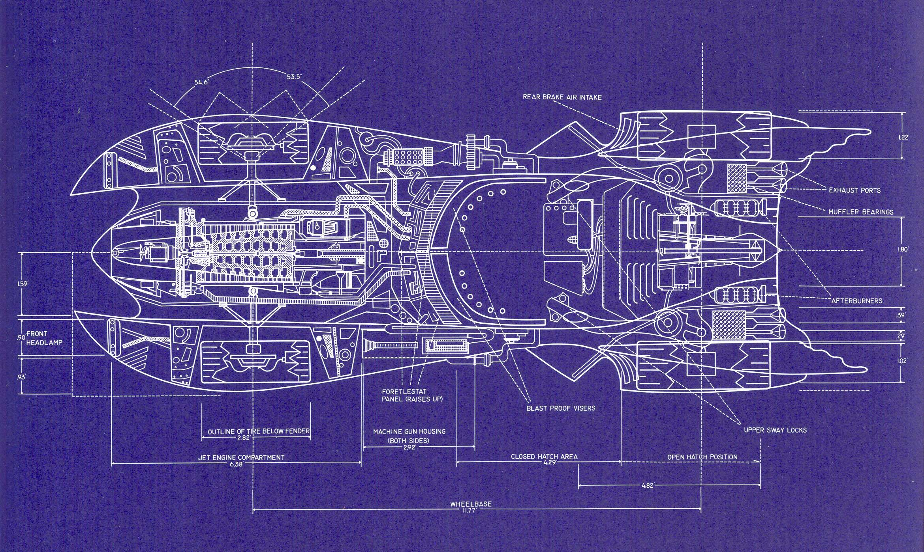 Unit 6.4
Synonyms: pattern, diagram, blueprint, plans

Antonyms: Unit 6.4

devise * Unit 6.4
When you devise something, you think up an idea and figure out how it will work. Unit 6.4

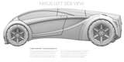 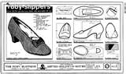 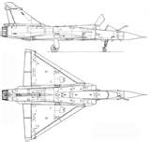Unit 6.4
Synonyms: brainstorm, construct, concoct, craft, create

Antonyms: borrow an idea Unit 6.4

ingenious Unit 6.4
If someone is ingenious, they are clever and full of imagination. Unit 6.4

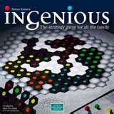   Unit 6.4
Synonyms: crafty, creative, skillful, imaginative, innovative, resourceful

Antonyms: awkward, inept, incompetent Unit 6.4

investigate Unit 6.4
To investigate is to examine, study,
check into thoroughly, or inquire. Unit 6.4

   Unit 6.4
Synonyms: delve, probe, pry, question, scrutinize, research

Antonyms: ignore Unit 6.4

superior * Unit 6.4
When something is superior it is very good or higher in quality than other things like it. Unit 6.4

   Unit 6.4
Synonyms: admirable, deluxe, distinguished, preferable, remarkable

Antonyms: bad, below, inferior, lower Unit 6.4

Name ____________________________________ Synonym Stretch Unit 6.4
brainstorm  blueprint  hammer | crafty  equipment  strong | dream up  created  scheme | scrutinize  invincible  design | Word Bank  forceful  consent  study | distinguished  inventive  think out | permit  grant  resourceful | superhuman  outstanding  mighty | tool  equipment  goods | merchandise  excellence  plan
Allowed | Powerful | Invented | Instrument | Products | Design | Devise * | Ingenious * | Investigate * | Superior *

